Lesson 1 Hands On

Part 1

1. Query all columns for actors with the first name of "Cuba".



1. Query the film title and film id that has an film_id greater than 5 and less than 20.

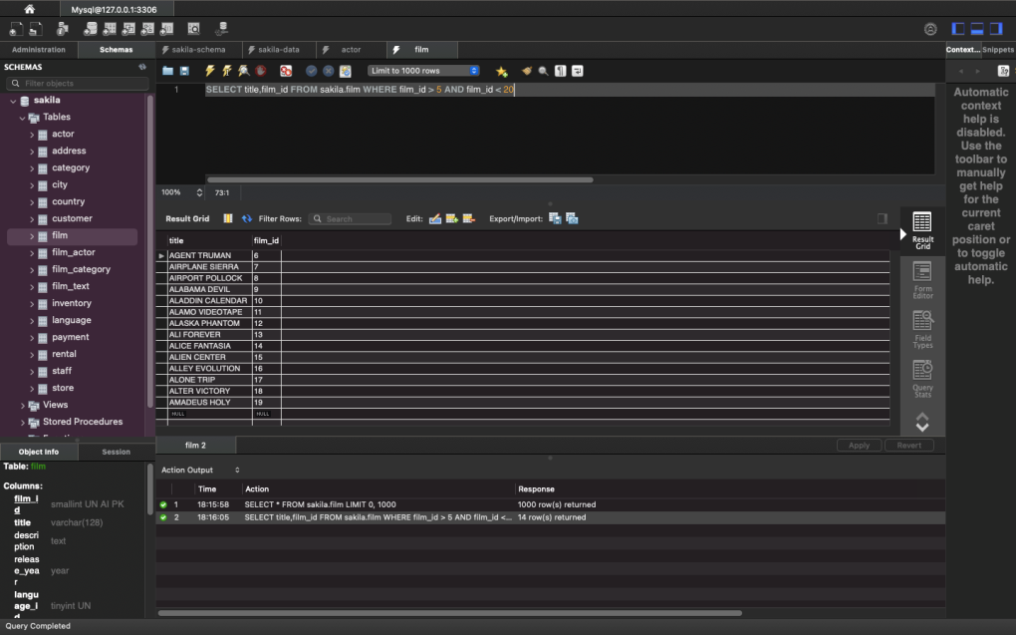

1. Query the first and last name, and email of customers who have the last name "Rodriguez" or their last name begins with a "Mc".

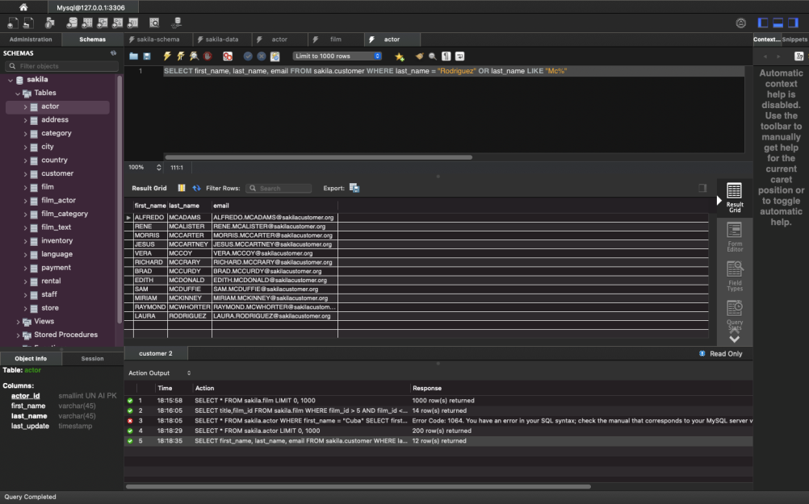

1. Query all columns of the films with a title that begins with "a".

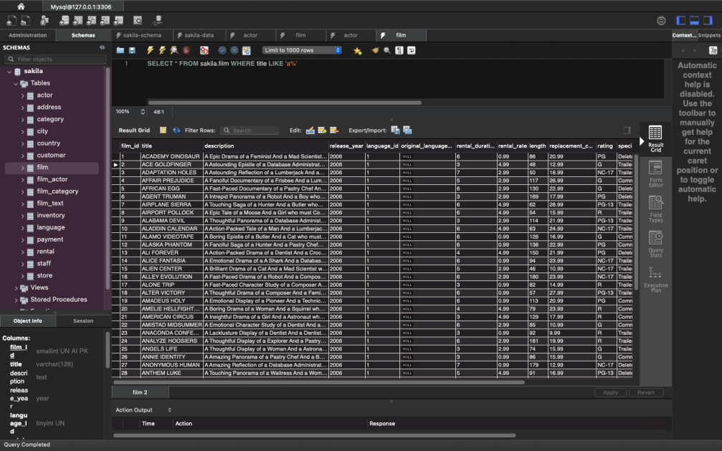

5. Query all titles of films that are not in the language of English or Japanese.

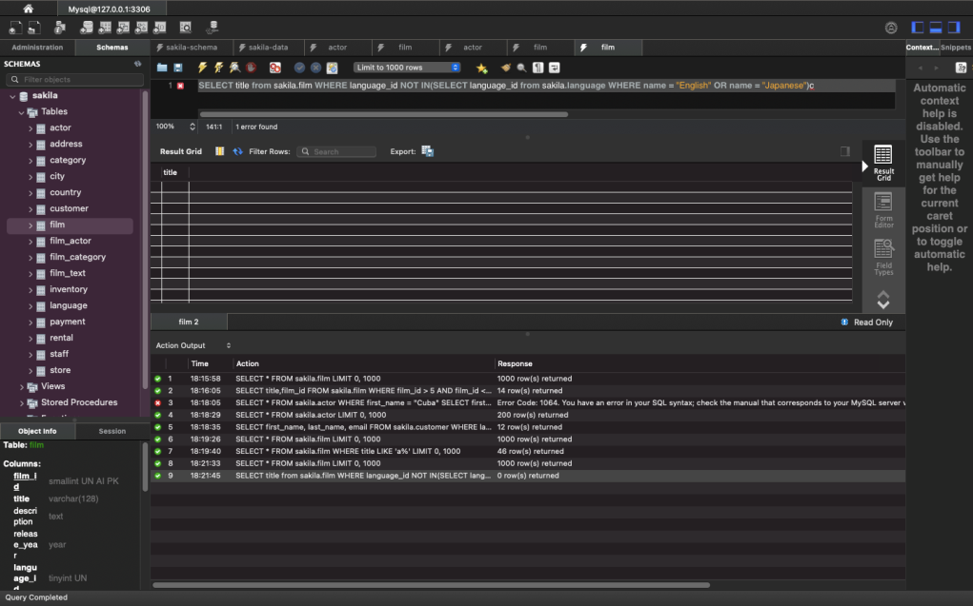

PART 2

You were just hired at a company as a data analyst, and your company needs some information from the database. They would like to see all payments that had a rental amount is over .99 cents. However, they only want to see the rental id and payment date that is attached to that payment. Once you have finished that, they would like to see the staff id and customer id from the payments that have an amount over .99 cents.

1.

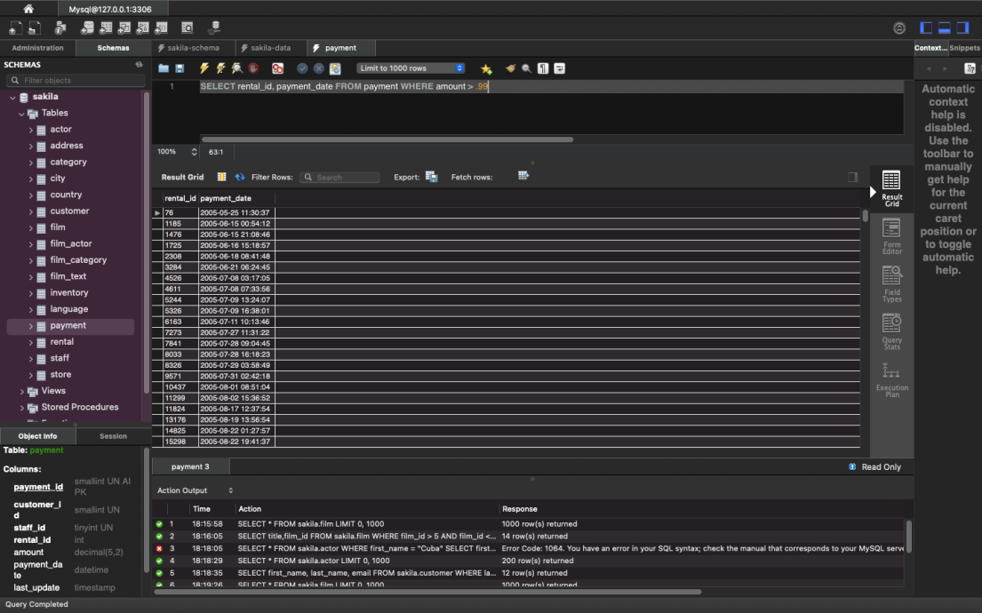

2.

